Sound and Symbol of the letter‘s’ ‘a’ and ‘t’
Objective:
- Children will be able to recognise the sounds and symbols of the letter ‘s’ ‘a’ and ’t’
- Children will be able to develop fine motor skills.
Instructions: Connect the letter with the picture which starts with the sound of the letter using thread/string. (Laminate the worksheet before use)
_____________________________________________________________________________________
s | 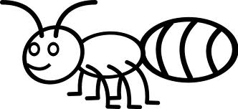
a | 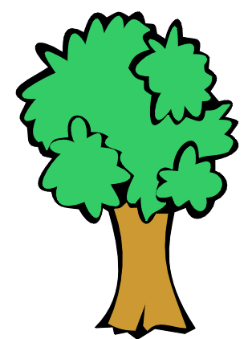
t

